Type of event | Workshop-Convention
Where it was held | Aula Magna – Hospital “Maggiore della Carità”, Novara
Who the organisers were | Ciro Isidoro (Italy), Gianluca Gaidano (Italy), Danny Dhanasekaran (USA) and Gloria Su (USA).
Duration | From 29/10/2017 to 30/10/2017
Attendees | 120 attendees among doctors, researchers and scientists from Nice (France), Berlin (Germany), Genoa (Italy), Milan (Italy), Barcelona (Spain), Oklahoma City (USA), New York (USA), San Francisco (USA) and Bellinzona (Switzerland)
Services offered | Welcoming the guests, transfer from/to the airport or from/to the railway station, light lunch, accommodation at Hotel Europa, coffee break, lunch break
Social programme | City Tour, classical music concert at Music hall G. Cantelli, welcome dinner-aperitif, farewell cocktail accompanied by a musical performance, Gala Dinner accompanied by a musical performance
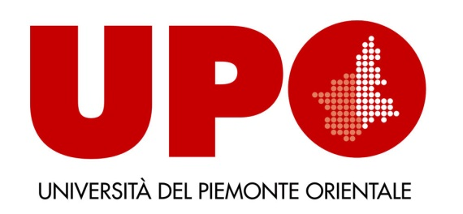
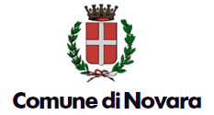
International Workshop No-Cancer 29-30 October 2017
From Cancerogenesis to Therapy: New Paradigms, New Opportunities

